UNSC Resolution: | 812
Date of adoption: | 12 March 1993
Operative paragraph: | 1
Demand number: | 812.0111

Carla Winston

Wording of demand
Respect the cease-fire which took effect on 9 March 1993, allow the delivery of humanitarian supplies and the return of displaced persons, fulfil the obligations they have accepted in the agreements they have signed and implement the commitments they have undertaken in their above-mentioned statements and joint communique

List of addressees of the demand
Rwandan Patriotic Front, Government of Rwanda

Short-term compliance

Description of the addressee(s)’ conduct
“…In February hundreds of thousands of Rwandans took refuge here, fleeing a civil war that has gradually pushed them out of their homes in the north. For some, it is the third camp they have fled to in three years, each move marking a deeper foray into Rwandan territory by the guerrillas.
…Like Mr. Nsenaiyumva, Rwanda itself is in limbo, its fabric torn apart by the civil war. A cease-fire in March lured several thousand families back to their homes in a demilitarized zone, but they live without food or livelihood, surviving mostly on weekly Red Cross food handouts.
Yearlong peace talks between the Government and the Rwandan Patriotic Front broke down at the end of June, and the will to negotiate evaporated. Now Rwandans, particularly the nearly one million displaced Rwandans, remain pawns in a three-year conflict that is rooted in ethnic hatreds but spurred on by political ambitions and modern weapons.
"There is an immense production loss for the whole country," said Walter Stocker, head of the International Committee of the Red Cross, which coordinates the distribution of 12,000 tons of food a month to the refugees from its Rwandan headquarters in Kigali, the capital.
"Sixty percent of the total agricultural production was in the north," Mr. Stocker said. "Now the Rwandan Patriotic Front is holding a territory without a population and on the other side there is a population without a territory.”
(“Kigali Journal; Refugees Trying to Flee a War Settle for Limbo.” By Donatella Lorch. The New York Times, July 8, 1993, p. A4)
**Arusha Peace Agreement signed August 5, 1993.

Assessment

Short-term compliance
No or marginal compliance (1) | Medium low compliance (2) | Medium high compliance (3) | Full or almost full compliance (4)

Considerations underlying the assessment
Cease-fire respected and humanitarian aid delivered, but delays in both return of displaced persons and implementing commitments to negotiate an end to the war.

Medium-term compliance

Description of the addressee(s)’ conduct
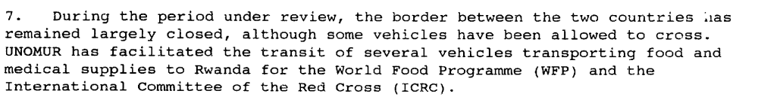(Report 1993-12-15, par. 7)
Through their respect of the cease-fire, the parties have demonstrated that they remain committed to the peace process set out in the agreement. This is, without doubt, a positive development. However, despite the cease-fire, commensurate progress has not been made in the political process.
(SECOND PROGRESS REPORT OF THE SECRETARY-GENERAL ON THE UNITED NATIONS ASSISTANCE MISSION FOR RWANDA, S/1994/360 (30 March 1994), par. 45)

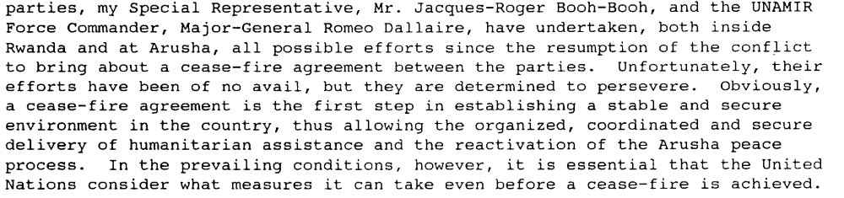
(Report of the Secretary-General on the Situation in Rwanda, UN Doc. S/1994/565 (13 May 1994), par. 4)

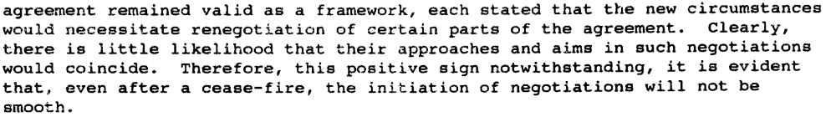
(Report of the Secretary-General on the Situation in Rwanda, UN Doc. S/1994/640 (30 May 1994), par. 29)

3. As members of the Security Council are aware, since the cease-fire declared on 18 July 1994, the fighting in Rwanda has all but ceased. The Broad-based Government of National Unity (BBGNU), installed at Kigali on 19 July, has established control over the whole of the national territory. While over two million Rwandese refugees remain in the neighbouring countries, the Government has undertaken efforts, in coordination with my Special Representative and other United Nations officials on the ground, to encourage their safe and voluntary return to Rwanda. At the same time, there is steady progress in efforts to normalize the situation inside Rwanda, with the gradual re-establishment of such basic services as water, electricity and communications facilities, particularly at Kigali. The Government has also begun to put civilian administrative structures in place at the central, provincial and local levels.
(Progress report of the Secretary-General on the United Nations Assistance Mission for Rwanda, UN Doc. S/1994/1133 (6 October 1994), par. 3)

Assessment

Medium-term compliance
No or marginal compliance (1) | Medium low compliance (2) | Medium high compliance (3) | Full or almost full compliance (4)

Considerations underlying the assessment
There was a genocide, and the refugee crisis created by the incitement of the Government of Rwanda as it was pushed out of the country by the RPF both impeded the return of supplies and created more displaced persons. After the re-declared ceasefire, compliance by the Government of Rwanda (which basically was the RPF) became stronger, and the government did all it could to encourage refugee return, but a genocide is too strong a variable to change the level of overall compliance.

Depth of demand

Assessment

Level of depth of demand
Low depth of demand (1) | Medium depth of demand (2) | High depth of demand (3)

Considerations underlying the assessment

Level of confidence about coding decisions

Level of confidence about coding decision
Extremely high | High | Moderate

Comments to IPI (if any)

Civil war in Rwanda

UNSC Resolution: | 812
Date of adoption: | 12 March 1993
Operative paragraph: | 6
Demand number: | 812.0611

Carla Winston

Wording of demand
Cooperate fully with the efforts of the United Nations and the OAU

List of addressees of the demand
Rwandan Patriotic Front, Government of Rwanda

Short-term compliance

Description of the addressee(s)’ conduct

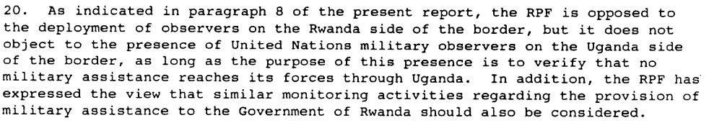
(1993-05-20, par. 10, 20)

Assessment

Short-term compliance
No or marginal compliance (1) | Medium low compliance (2) | Medium high compliance (3) | Full or almost full compliance (4)

Considerations underlying the assessment
Compliance, but not exactly in the way the UN would have preferred.

Medium-term compliance

Description of the addressee(s)’ conduct

9. The prolonged delay in putting the transitional institutions in place has not only prevented UNAMIR from carrying out its tasks in accordance with the implementation schedule approved by the Security Council, but has also contributed to a deterioration of the security situation in the country and posed a threat to the peace process. The failure to establish the broad-based transitional Government constitutes a serious impediment to the implementation of the Arusha peace agreement and to the smooth functioning of State institutions.
(SECOND PROGRESS REPORT OF THE SECRETARY-GENERAL ON THE UNITED NATIONS ASSISTANCE MISSION FOR RWANDA, S/1994/360 (30 March 1994), par. 9)

**10 Belgian U.N peacekeepers are killed early in the genocide.

11. … Meanwhile, the situation in Rwanda has continued to deteriorate and the killing of innocent civilians has not been stopped. Furthermore, the parties have not yet come to an agreement for a cease-fire in the talks under UNAMIR auspices, nor have they respected the cease-fire to which they agreed at the recent OAU summit in Tunis.
(Letter dated 19 June 1994 from the Secretary-General addressed to the President of the Security Council, UN Doc. S/1994/728 (20 June 1994), par. 11)

3. As members of the Security Council are aware, since the cease-fire declared on 18 July 1994, the fighting in Rwanda has all but ceased. The Broad-based Government of National Unity (BBGNU), installed at Kigali on 19 July, has established control over the whole of the national territory. While over two million Rwandese refugees remain in the neighbouring countries, the Government has undertaken efforts, in coordination with my Special Representative and other United Nations officials on the ground, to encourage their safe and voluntary return to Rwanda. At the same time, there is steady progress in efforts to normalize the situation inside Rwanda, with the gradual re-establishment of such basic services as water, electricity and communications facilities, particularly at Kigali. The Government has also begun to put civilian administrative structures in place at the central, provincial and local levels.
(Progress report of the Secretary-General on the United Nations Assistance Mission for Rwanda, UN Doc. S/1994/1133 (6 October 1994), par. 3)

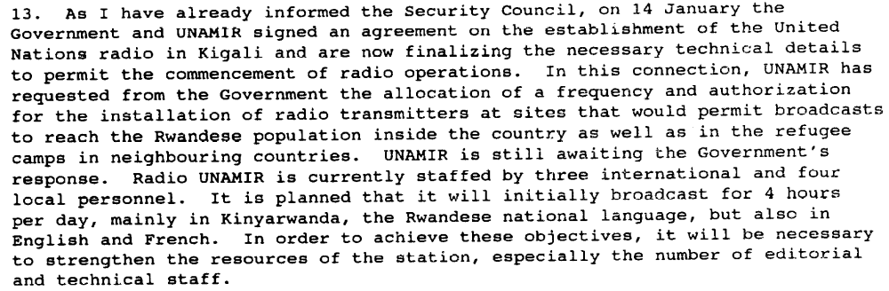
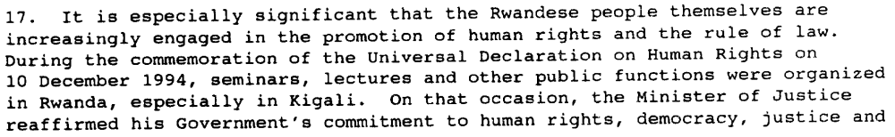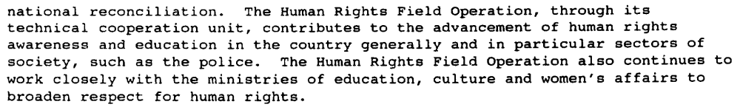
(Progress Report of the Secretary-General on the United Nations Assistance Mission for Rwanda, UN Doc. S/1995/107 (6 February 1995), par. 13, 17)

Assessment

Medium-term compliance
No or marginal compliance (1) | Medium low compliance (2) | Medium high compliance (3) | Full or almost full compliance (4)

Considerations underlying the assessment
Although the Government of Rwanda complied almost fully with both the UN and the OAU after the genocide (at which time it was controlled by the RPF), the magnitude of non-compliance represented by the wanton murder of peacekeepers and the execution of the genocide itself cannot be discounted.

Depth of demand

Assessment

Level of depth of demand
Low depth of demand (1) | Medium depth of demand (2) | High depth of demand (3)

Considerations underlying the assessment

Level of confidence about coding decisions

Level of confidence about coding decision
Extremely high | High | Moderate

Comments to IPI (if any)

There are several drastic swings in level of compliance dependent on the before/after genocide variable, when one party to the conflict essentially became the Government of Rwanda. As the genocide was planned and in many cases carried out by the originally named Government of Rwanda, compliance is obviously low. However, the RPF-controlled, post-genocide Government of Rwanda made strong efforts to comply with UN resolutions. I fear that there will be many low- or medium low-compliance scores based at least partially in this drastic shift in government.

Civil war in Rwanda

UNSC Resolution: | 812
Date of adoption: | 12 March 1993
Operative paragraph: | 7
Demand number: | 812.0711

Carla Winston

Wording of demand
Resume the negotiations on 15 March 1993 as agreed, in order to resolve the pending questions with a view to signing a peace agreement at the beginning of April 1993 at the latest

List of addressees of the demand
Rwandan Patriotic Front, Government of Rwanda

Short-term compliance

Description of the addressee(s)’ conduct
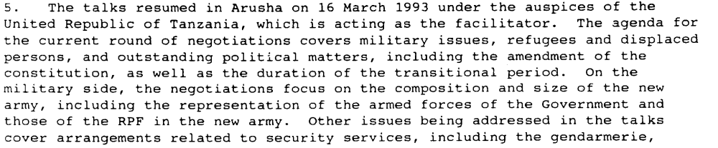(Interim Report of the Secretary-General on Rwanda, UN Doc. S/25810 (20 May 1993), par. 5)

Assessment

Short-term compliance
No or marginal compliance (1) | Medium low compliance (2) | Medium high compliance (3) | Full or almost full compliance (4)

Considerations underlying the assessment
Talks resumed almost on schedule with most substantive issues discussed, but no Agreement was reached until well past April 1993.

Medium-term compliance

Description of the addressee(s)’ conduct
The peace agreement was signed, but not respected (there was a genocide), and there was no attempt to negotiate a new agreement.

Assessment

Medium-term compliance
No or marginal compliance (1) | Medium low compliance (2) | Medium high compliance (3) | Full or almost full compliance (4)

Considerations underlying the assessment
The medium-term compliance of this demand seems a moot question; the demand asked for a specific and one-time response (sign a peace agreement), which happened during the short term.

Depth of demand

Assessment

Level of depth of demand
Low depth of demand (1) | Medium depth of demand (2) | High depth of demand (3)

Considerations underlying the assessment
The terms of said agreement could significantly impact the ability to hold or retain power in the future, so negotiating in good faith was a bit risky.

Level of confidence about coding decisions

Level of confidence about coding decision
Extremely high | High | Moderate

Comments to IPI (if any)

Confidence extremely high for short term, only moderate for medium term.

Civil war in Rwanda

UNSC Resolution: | 812
Date of adoption: | 12 March 1993
Operative paragraph: | 8
Demand number: | 812.0811

Carla Winston

Wording of demand
Strictly respect the rules of international humanitarian law

List of addressees of the demand
Rwandan Patriotic Front, Government of Rwanda

Short-term compliance

Description of the addressee(s)’ conduct

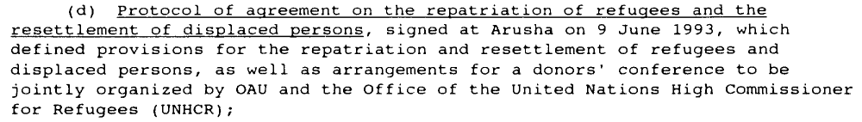 (Source: Further Report of the Secretary-General on Rwanda, UN Doc. S/26350 (24 August 1993), par. 20d)

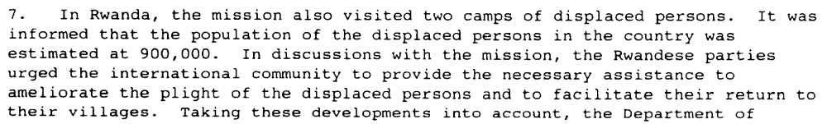(Further Report of the Secretary-General on Rwanda, UN Doc. S/26350 (24 August 1993), par. 7)

Assessment

Short-term compliance
No or marginal compliance (1) | Medium low compliance (2) | Medium high compliance (3) | Full or almost full compliance (4)

Considerations underlying the assessment

Medium-term compliance

Description of the addressee(s)’ conduct

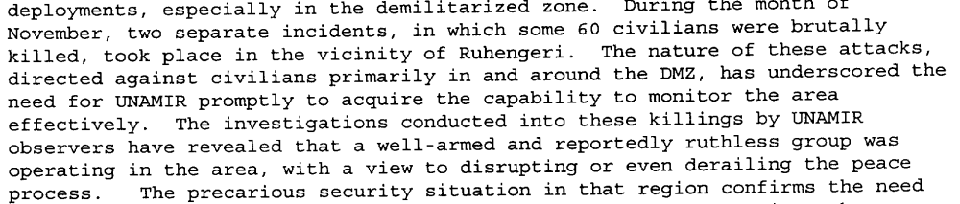(Report of the Secretary-General on the United Nations Assistance Mission for Rwanda, UN Doc. S/26927, 30 December 1993, par. 18)

The massacres were planned for months in advance. The Presidential Guard and other elements of the Rwandan army taught members of the political party militias, the Interahamwe and the Impuzamugambi, how to kill most efficiently. … Created in 1992, the militias received intensified military training in late 1993 and early 1994, as groups of 300 men at a time were sent for three weeks to a military camp in the northeastern region of Mutara. In their attacks on civilians, the militia are often accompanied by a small number of soldiers or national policemen, but the militia have killed far more people than have uniformed members of the armed forces.
The Rwandan authorities distributed firearms to militia members and other Habyarimana supporters as early as 1992, and gave out many more in late 1993 and early 1994. … The militia who returned from training programs in early 1994 brought firearms, including grenades, back with them.
A private radio station owned by members of Habyarimana’s inner circle, the Radio Télévision Libre des Milles Collines, last autumn began a campaign of hate-filled propaganda against the Tutsi generally and members of the opposition to the Habyarimana regime, both Tutsi and Hutu. At the end of 1993, the broadcasts became more virulent and began targeting individuals who were named as "enemies" or "traitors" who "deserved to die." Among those so labeled were Lando Ndasingwa, Minister of Labor and Social Affairs, who was one of the first killed once the massacres began (along with his mother, his wife and his children), and Monique Mujawamariya, a human rights activist, who narrowly escaped with her life.
Throughout these weeks of slaughter, the Radio des Milles Collines has incited listeners to genocide, encouraging them to "fill the half-empty graves."
(Human Rights Watch, “Genocide in Rwanda April-May 1994.” Vol. 6 no. 4 (May 1994), P. 2, http://www.hrw.org/sites/default/files/reports/RWANDA945.PDF)

There was a genocide.

Assessment

Medium-term compliance
No or marginal compliance (1) | Medium low compliance (2) | Medium high compliance (3) | Full or almost full compliance (4)

Considerations underlying the assessment
The magnitude of a genocide overrules the relative significance of any attempts at compliance by the other party.

Depth of demand

Assessment

Level of depth of demand
Low depth of demand (1) | Medium depth of demand (2) | High depth of demand (3)

Considerations underlying the assessment

Level of confidence about coding decisions

Level of confidence about coding decision
Extremely high | High | Moderate

Comments to IPI (if any)

There are several drastic swings in level of compliance dependent on the before/after genocide variable, when one party to the conflict essentially became the Government of Rwanda. As the genocide was planned and in many cases carried out by the originally named Government of Rwanda, compliance is obviously low. However, the pre-genocide RPF and the RPF-controlled, post-genocide Government of Rwanda generally made strong efforts to comply with UN resolutions.

Civil war in Rwanda

UNSC Resolution: | 846
Date of adoption: | 22 June 1993
Operative paragraph: | 6
Demand number: | 846.0611

Carla Winston

Wording of demand
Strictly respect the rules of international humanitarian law

List of addressees of the demand
Rwandan Patriotic Front, Government of Rwanda

Short-term compliance

Description of the addressee(s)’ conduct
(Report of the Secretary-General on the United Nations Assistance Mission for Rwanda, UN Doc. S/26927, 30 December 1993, par. 18)

Assessment

Short-term compliance
No or marginal compliance (1) | Medium low compliance (2) | Medium high compliance (3) | Full or almost full compliance (4)

Considerations underlying the assessment
The RPF was not accused of any incidents during this period, and although there were incidents connected to the Government of Rwanda’s associated militias during this time, the majority of the preparation work for the genocide occurred just after the six-month short term (see references in medium-term description).

Medium-term compliance

Description of the addressee(s)’ conduct

The massacres were planned for months in advance. The Presidential Guard and other elements of the Rwandan army taught members of the political party militias, the Interahamwe and the Impuzamugambi, how to kill most efficiently. … Created in 1992, the militias received intensified military training in late 1993 and early 1994, as groups of 300 men at a time were sent for three weeks to a military camp in the northeastern region of Mutara. In their attacks on civilians, the militia are often accompanied by a small number of soldiers or national policemen, but the militia have killed far more people than have uniformed members of the armed forces.
The Rwandan authorities distributed firearms to militia members and other Habyarimana supporters as early as 1992, and gave out many more in late 1993 and early 1994. … The militia who returned from training programs in early 1994 brought firearms, including grenades, back with them.
A private radio station owned by members of Habyarimana’s inner circle, the Radio Télévision Libre des Milles Collines, last autumn began a campaign of hate-filled propaganda against the Tutsi generally and members of the opposition to the Habyarimana regime, both Tutsi and Hutu. At the end of 1993, the broadcasts became more virulent and began targeting individuals who were named as "enemies" or "traitors" who "deserved to die." Among those so labeled were Lando Ndasingwa, Minister of Labor and Social Affairs, who was one of the first killed once the massacres began (along with his mother, his wife and his children), and Monique Mujawamariya, a human rights activist, who narrowly escaped with her life.
Throughout these weeks of slaughter, the Radio des Milles Collines has incited listeners to genocide, encouraging them to "fill the half-empty graves."
(Human Rights Watch, “Genocide in Rwanda April-May 1994.” Vol. 6 no. 4 (May 1994), P. 2, http://www.hrw.org/sites/default/files/reports/RWANDA945.PDF)

There was a genocide.

Assessment

Medium-term compliance
No or marginal compliance (1) | Medium low compliance (2) | Medium high compliance (3) | Full or almost full compliance (4)

Considerations underlying the assessment

There was a genocide. In addition, the RPF, once it re-engaged in the civil war, was also guilty of a number of war crimes, although on a much smaller scale than the Government of Rwanda.

Depth of demand

Assessment

Level of depth of demand
Low depth of demand (1) | Medium depth of demand (2) | High depth of demand (3)

Considerations underlying the assessment

Level of confidence about coding decisions

Level of confidence about coding decision
Extremely high | High | Moderate

Comments to IPI (if any)

There are several drastic swings in level of compliance dependent on the before/after genocide variable, when one party to the conflict essentially became the Government of Rwanda. As the genocide was planned and in many cases carried out by the originally named Government of Rwanda, compliance is obviously low. However, the RPF-controlled, post-genocide Government of Rwanda made strong efforts to comply with UN resolutions.

Civil war in Rwanda

UNSC Resolution: | 846
Date of adoption: | 22 June 1993
Operative paragraph: | 7
Demand number: | 846.0711

Carla Winston

Wording of demand
Refrain from any action that could contribute to tension

List of addressees of the demand
Rwandan Patriotic Front, Government of Rwanda

Short-term compliance

Description of the addressee(s)’ conduct
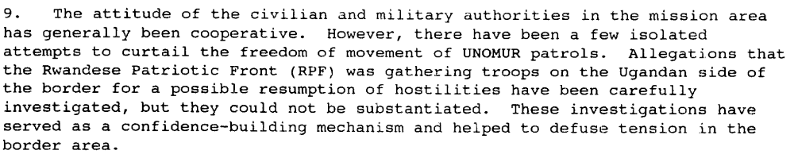 (Second Report of the Secretary-General on the United Nations Observer Mission Uganda-Rwanda, UN Doc. S/26878, 15 December 1993, par. 9)

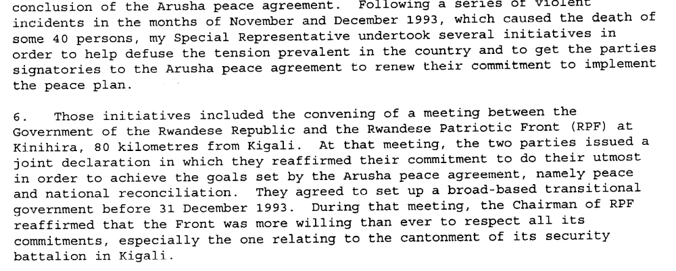(Report of the Secretary-General on the United Nations Assistance Mission for Rwanda, UN Doc. S/26927, 30 December 1993, par. 5-6)

Assessment

Short-term compliance
No or marginal compliance (1) | Medium low compliance (2) | Medium high compliance (3) | Full or almost full compliance (4)

Considerations underlying the assessment
Good at the beginning but less compliant towards the end as the Government of Rwanda began secretly planning for the genocide.

Medium-term compliance

Description of the addressee(s)’ conduct
27. Owing in part to the continuing political stalemate, the period under review has seen a rapid and dramatic deterioration in the security situation in Kigali. January and February saw increasingly violent demonstrations, roadblocks, assassination of political leaders and assaults on and murders of civilians, developments that severely overstretched the resources and capabilities of the national gendarmerie. Following an upsurge in violent incidents in late February, culminating in the assassination of two prominent political leaders and the ambush of a UNAMIR-escorted RPF convoy, the Government imposed a curfew in Kigali and in other cities. Furthermore, UNAMIR and the United Nations community in Kigali moved into phase II security status for a period of about three weeks. The United Nations community has since returned to the phase I security status, as the security situation has begun to stabilize, especially following the increased support provided to the gendarmerie by UNAMIR military and civilian police components.
(SECOND PROGRESS REPORT OF THE SECRETARY-GENERAL ON THE UNITED NATIONS ASSISTANCE MISSION FOR RWANDA, UN Doc. S/1994/360, of 30 March 1994, par. 27)

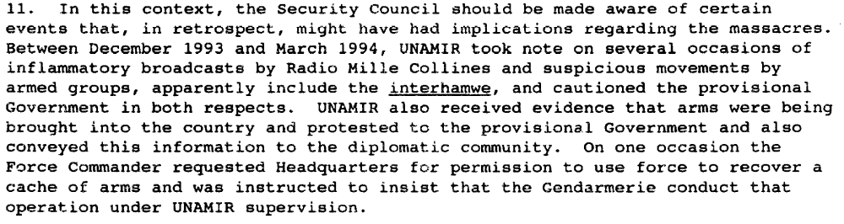
(Report of the Secretary-General on the Situation in Rwanda, UN Doc. S/1994/640 (30 May 1994), par. 11)

The massacres were planned for months in advance. The Presidential Guard and other elements of the Rwandan army taught members of the political party militias, the Interahamwe and the Impuzamugambi, how to kill most efficiently. … Created in 1992, the militias received intensified military training in late 1993 and early 1994, as groups of 300 men at a time were sent for three weeks to a military camp in the northeastern region of Mutara. In their attacks on civilians, the militia are often accompanied by a small number of soldiers or national policemen, but the militia have killed far more people than have uniformed members of the armed forces.
The Rwandan authorities distributed firearms to militia members and other Habyarimana supporters as early as 1992, and gave out many more in late 1993 and early 1994. … The militia who returned from training programs in early 1994 brought firearms, including grenades, back with them.
A private radio station owned by members of Habyarimana’s inner circle, the Radio Télévision Libre des Milles Collines, last autumn began a campaign of hate-filled propaganda against the Tutsi generally and members of the opposition to the Habyarimana regime, both Tutsi and Hutu. At the end of 1993, the broadcasts became more virulent and began targeting individuals who were named as "enemies" or "traitors" who "deserved to die." Among those so labeled were Lando Ndasingwa, Minister of Labor and Social Affairs, who was one of the first killed once the massacres began (along with his mother, his wife and his children), and Monique Mujawamariya, a human rights activist, who narrowly escaped with her life.
Throughout these weeks of slaughter, the Radio des Milles Collines has incited listeners to genocide, encouraging them to "fill the half-empty graves."
(Human Rights Watch, “Genocide in Rwanda April-May 1994.” Vol. 6 no. 4 (May 1994), P. 2, http://www.hrw.org/sites/default/files/reports/RWANDA945.PDF)

There was a genocide.

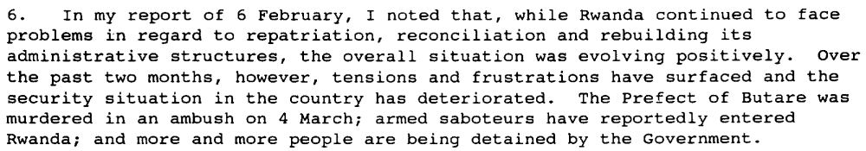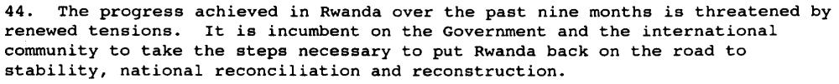
(Progress Report of the Secretary-General on the United Nations Assistance Mission for Rwanda, UN Doc. s/1995/297 (9 April 1995), par. 6, 44)

Assessment

Medium-term compliance
No or marginal compliance (1) | Medium low compliance (2) | Medium high compliance (3) | Full or almost full compliance (4)

Considerations underlying the assessment
The magnitude of a genocide, followed by the resumption of civil war by the RPF, dwarfs any later attempts to refrain from tension.

Depth of demand

Assessment

Level of depth of demand
Low depth of demand (1) | Medium depth of demand (2) | High depth of demand (3)

Considerations underlying the assessment
The Government of Rwanda believed that the Arusha agreement, as signed, significantly weakened its power, and to refrain from tensions would have been a blow to its ability to gain that power back. The RPF could have survived as a political entity even after the genocide, since it was able to defend itself and located in non-government-controlled areas of Rwanda.

Level of confidence about coding decisions

Level of confidence about coding decision
Extremely high | High | Moderate

Comments to IPI (if any)

Civil war in Rwanda

UNSC Resolution: | 846
Date of adoption: | 22 June 1993
Operative paragraph: | 9
Demand number: | 846.0911

Carla Winston

Wording of demand
Conclude quickly a comprehensive peace agreement

List of addressees of the demand
Rwandan Patriotic Front, Government of Rwanda

Short-term compliance

Description of the addressee(s)’ conduct
The Arusha Peace Agreement was signed August 4, 1993.

Assessment

Short-term compliance
No or marginal compliance (1) | Medium low compliance (2) | Medium high compliance (3) | Full or almost full compliance (4)

Considerations underlying the assessment
Speed (6 weeks from UNSC Res.) is a little bit long considering the word “quickly” in the demand.

Medium-term compliance

Description of the addressee(s)’ conduct
(Report of the Secretary-General on the Situation in Rwanda, UN Doc. S/1994/640 (30 May 1994), par. 29)

43. … They commended the Government of Rwanda for the steps it has so far taken to establish a broad-based government administration and urged the Government, towards this end, to deepen its efforts, in the spirit of the Arusha peace accord.
(Second Report of the Secretary-General on Security in the Rwandese Refugee Camps, UN Doc. S/1995/65 (25 January 1995), par. 43)

10. Government officials also emphasized that they respected, and indeed accepted the spirit of an inclusive and broad-based Government, as provided for under the Arusha peace agreement, to which their Government remained fully committed. It was pointed out that the Arusha accords were part of Rwanda’s fundamental or basic law ("loi fondamentale"). They further pointed out, however, that returning to the country was the precondition for participating in the political process. Officials also indicated that the Government had recently commenced dialogue with representatives of Rwandese refugee communities
in Burundi. They explained that dialogue with the refugee community in Zaire was not yet feasible in view of the insecurity and intimidation to which those refugees were subjected by armed elements in their midst.
(Report of the Security Council Mission to Rwanda on 12 and 13 February 1995, UN Doc. S/1995/164 (28 February 1995), par. 10)

Assessment

Medium-term compliance
No or marginal compliance (1) | Medium low compliance (2) | Medium high compliance (3) | Full or almost full compliance (4)

Considerations underlying the assessment
Again, the medium-term assessment seems moot, since the demand was for a specific, one-time action (conclude a peace agreement), which was accomplished in the short term. However, in the medium term, that agreement was abandoned in letter and spirit by one of the parties, and in letter but not spirit by the other.

Depth of demand

Assessment

Level of depth of demand
Low depth of demand (1) | Medium depth of demand (2) | High depth of demand (3)

Considerations underlying the assessment

Level of confidence about coding decisions

Level of confidence about coding decision
Extremely high | High | Moderate

Comments to IPI (if any)

Civil war in Rwanda

UNSC Resolution: | 872
Date of adoption: | 5 October 1993
Operative paragraph: | 11
Demand number: | 872.1111

Carla Winston

Wording of demand
Implement the Arusha Agreement in good faith

List of addressees of the demand
Rwandan Patriotic Front, Government of Rwanda

Short-term compliance

Description of the addressee(s)’ conduct
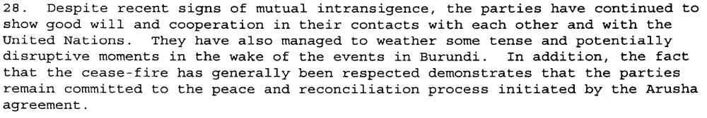
(Report of the Secretary-General on the United Nations Assistance Mission for Rwanda, UN Doc. S/26927, 30 December 1993, par. 28)

6. Despite the fact that the Rwandese Government and the Rwandese Patriotic Front (RPF) had agreed at Kinihira on 10 December 1993 to set up the broad-based transitional Government and the Transitional National Assembly before 31 December, this did not take place as a result of the inability of the parties concerned to agree on the relevant modalities, including the lists of members of the broad-based transitional Government and the Transitional National Assembly.

7. In accordance with the Arusha peace agreement, which provided that the incumbent head of State would remain in office until the outcome of elections to be held at the end of the transitional period, Major-General Juvénal Habyarimana was sworn in as President of the Republic on 5 January 1994. Expectations that the broad-based transitional Government and the Transitional National Assembly would also be installed on that same day could not be met because of continuing difficulties, especially within the Parti libéral (Liberal Party) and the Mouvement démocratique républicain (Democratic Republican Movement), regarding the lists of their representatives to serve as ministers in the broad-based transitional Government and as deputies in the Transitional National Assembly…The failure to establish the broad-based transitional Government constitutes a serious impediment to the implementation of the Arusha peace agreement and to the smooth functioning of State institutions.

10. While various Rwandese political leaders have also recognized the urgent need to establish the broad-based transitional Government and the Transitional National Assembly in order to ensure the smooth and orderly functioning of the country, they nevertheless remain deadlocked on the modalities for putting those institutions in place. My Special Representative and I have stressed to the Rwandese political leaders that, without the early establishment of the broad-based transitional Government and the Transitional National Assembly, it would be difficult to affirm that sufficient progress has been made in the implementation of the Arusha peace agreement to warrant the continued support of the international community.

12. Following a series of all-party consultations that my Special
Representative organized at UNAMIR headquarters in Kigali on 7, 10 and
13 February, broad consensus was reached among the various political leaders to set up the transitional institutions on 14 February, while giving the Liberal Party more time to resolve its internal problems and to join those institutions later and leaving the courts to decide on the factional rift within the Democratic Republican Movement. However, reservations to the consensus were expressed by the Mouvement républicain national pour le développement et la démocratie (Republican National Movement for Development and Democracy) and by other elements close to the President, who argued that all outstanding problems should first be resolved before proceeding to set up the broad-based transitional Government and the Transitional National Assembly, so that all political parties concerned could participate in those institutions from the outset. Nevertheless, the key element in that consensus, which provides for the installation of the broad-based transitional Government and the Transitional National Assembly even if some political parties are not in a position to participate immediately, has continued to feature in the discussions among the Rwandese political leaders.

13. An agreement reached at meetings of the political parties on 16 and 18 February to establish the transitional institutions on 22 February was set back as a result of the sudden outbreak of violence in Kigali and in other regions of the country beginning on 21 February. This resurgence of violence, in the course of which two prominent political leaders, Mr. Félicien Gatabazi, the Minister of Public Works and Energy who was also the Secretary-General of the Parti social démocrate (Social Democrat Party), and Mr. Martin Buchyana, the President of the Coalition pour la défense de la république (Coalition for the Defence of the Republic), were murdered, an RPF soldier killed and a UNAMIR military observer wounded in an ambush, contributed to heightening tension and worsening the overall political climate. On 23 February, another effort to install the transitional institutions also failed when the ceremony organized for that purpose by President Habyarimana was boycotted by most political parties, including RPF, which in a press release issued on the same day accused the President of trying to impose a unilateral solution to the internal problems within the Liberal Party and the Democratic Republican Movement.

15. Following meetings held on 25 and 27 February at the initiative of the President, the five political parties represented in the current coalition Government indicated in a communiqué dated 27 February that agreement had been reached on a formula to resolve the internal problems within the Democratic Republican Movement but that a consensus had still not been reached on the rift within the Liberal Party owing to the reservations expressed by one of the leaders of that party. Following the announcement of the RPF’s rejection of the proposed compromise in a communiqué dated 28 February…

17. During visits to the United Republic of Tanzania by an RPF delegation and by President Habyarimana on 4 and 8 March respectively, the two signatories to the Arusha peace agreement sought the intervention of President Mwinyi of the United Republic of Tanzania, the Facilitator of the Rwandese peace process, to try to break the impasse in the implementation of the agreement. The Foreign Minister of the United Republic of Tanzania, Mr. Joseph C. Rwegasira, visited Rwanda from 11 to 18 March to assist the parties in resolving the outstanding issues that are impeding the establishment of the transitional institutions. He held intensive bilateral consultations with various Rwandese political and religious leaders as well as with members of the diplomatic corps, the representative in Rwanda of the Secretary-General of OAU and my Special Representative.

18. At the conclusion of his visit, the Foreign Minister of the United Republic of Tanzania stated that his consultations in Kigali had led him to conclude that the stumbling block to putting the transitional institutions in place revolved around the internal problems within the Liberal Party. He stressed that the delay in the political transition caused by the apparent power struggle within the Liberal Party was unacceptable, as it had no legal basis within the framework of the Arusha peace agreement. The proposed composition of the broad-based
transitional Government, he emphasized, was within the prerogative of the Prime Minister Designate, Mr. Faustin Twagiramungu, as long as he respected the lists of ministers proposed to him during consultations with each of the political forces concerned. The Tanzanian Minister also considered as unacceptable the rejection by RPF of the compromise reached within the Liberal Party on a formula for sharing the Party’s assigned seats in the transitional
Parliament.
19. The Prime Minister Designate, in a nationwide radio address on 18 March, announced the proposed composition of the broad-based transitional Government. The following day, the Prime Minister of the current coalition Government, Ms. Agathe Uwilingiyimana, announced the names of deputies for the Transitional National Assembly.

20. According to a communiqué issued on 21 March 1994, President Habyarimana met earlier that day with the Prime Minister Designate and informed him that he had received a letter dated 20 March, from one of the two factions of the Liberal Party, protesting against the Prime Minister Designate’s choice of candidate for Minister of Justice, a portfolio assigned to the Liberal Party under the Arusha peace agreement. The President requested the Prime Minister Designate to continue consultations with the Liberal Party with a view to reaching an agreement which, according to the President, should be based on the compromise formula reached on 27 February by which the three ministerial positions assigned to the Liberal Party should be divided in a two to one ratio between the Party’s two factions, with the faction receiving one ministerial portfolio nominating candidates for the Speaker or Deputy Speaker of the Transitional National Assembly.

21. According to the same communiqué, President Habyarimana believed that the list of deputies for the Transitional National Assembly, which he had received on 20 March from the Prime Minister of the current coalition Government, contained a number of anomalies impeding the installation of the Transitional National Assembly. The communiqué again called on the Prime Minister to ensure that the obstacles to the entry of the Coalition for the Defence of the Republic in the transitional Parliament were removed; ensure the representation of the
"Parti démocrate Islamique" (Islamic Democrat Party) in the Transitional National Assembly; and take into account the recent rulings on cases brought before the courts by some Democratic Republican Movement party members seeking to become members of the Transitional National Assembly. The communiqué concluded that the President would be prepared to preside over the ceremonies for the installation of the transitional institutions once the above-mentioned
concerns had been addressed.

22. Ceremonies for the installation of the transitional institutions that were scheduled to take place on 25 March 1994 were cancelled as there were still a number of outstanding issues to be resolved.

48. Progress made thus far in the negotiations suggests that a compromise could be reached on the transitional institutions. I am encouraged by the fact that,in spite of increasing tensions, the parties have maintained the process of dialogue.
(SECOND PROGRESS REPORT OF THE SECRETARY-GENERAL ON THE UNITED NATIONS ASSISTANCE MISSION FOR RWANDA, S/1994/360 (30 March 1994), par. 6-22, 48)

Assessment

Short-term compliance
No or marginal compliance (1) | Medium low compliance (2) | Medium high compliance (3) | Full or almost full compliance (4)

Considerations underlying the assessment
Considerably slow speed in establishing transitional institutions and increasing tensions.

Medium-term compliance

Description of the addressee(s)’ conduct

There was a genocide.

(Report of the Secretary-General on the Situation in Rwanda, UN Doc. S/1994/640 (30 May 1994), par. 29)

43. … They commended the Government of Rwanda for the steps it has so far taken to establish a broad-based government administration and urged the Government, towards this end, to deepen its efforts, in the spirit of the Arusha peace accord.
(Second Report of the Secretary-General on Security in the Rwandese Refugee Camps, UN Doc. S/1995/65 (25 January 1995), par. 43)

10. Government officials also emphasized that they respected, and indeed accepted the spirit of an inclusive and broad-based Government, as provided for under the Arusha peace agreement, to which their Government remained fully committed. It was pointed out that the Arusha accords were part of Rwanda’s fundamental or basic law ("loi fondamentale"). They further pointed out, however, that returning to the country was the precondition for participating in the political process. Officials also indicated that the Government had recently commenced dialogue with representatives of Rwandese refugee communities
in Burundi. They explained that dialogue with the refugee community in Zaire was not yet feasible in view of the insecurity and intimidation to which those refugees were subjected by armed elements in their midst.
(Report of the Security Council Mission to Rwanda on 12 and 13 February 1995, UN Doc. S/1995/164 (28 February 1995), par. 10)

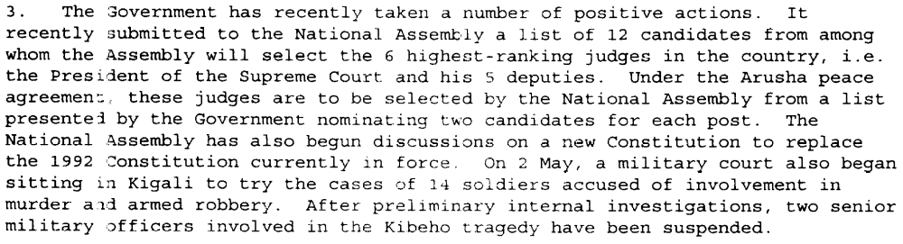
(Report of the Secretary-General on the United Nations Assistance Mission for Rwanda, UN Doc. S/1995/457 (4 June 1995), par. 3)

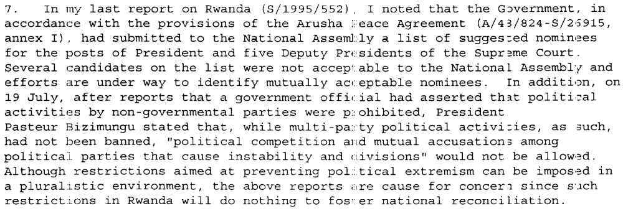(Progress Report of the Secretary-General on the United Nations Assistance Mission for Rwanda, UN Doc. S/1995/678 (8 August 1995), par. 7)

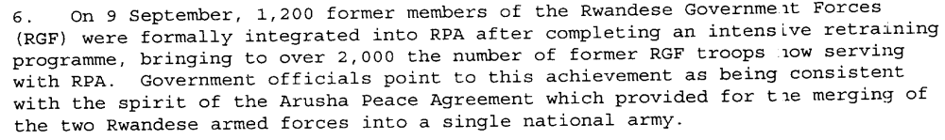
(Progress Report of the Secretary-General on the United Nations Assistance Mission for Rwanda, UN Doc. S/1995/848 (7 October 1995), par. 6, 17)

Assessment

Medium-term compliance
No or marginal compliance (1) | Medium low compliance (2) | Medium high compliance (3) | Full or almost full compliance (4)

Considerations underlying the assessment
The genocide began almost immediately after the 6-month short-term had ended, and dwarfs most later efforts by the Government of Rwanda and Rwandan Patriotic Front to implement the spirit, if not the letter, of the Arusha Agreement.

Depth of demand

Assessment

Level of depth of demand
Low depth of demand (1) | Medium depth of demand (2) | High depth of demand (3)

Considerations underlying the assessment

Level of confidence about coding decisions

Level of confidence about coding decision
Extremely high | High | Moderate

Comments to IPI (if any)

There are several drastic swings in level of compliance dependent on the before/after genocide variable, when one party to the conflict essentially became the Government of Rwanda. As the genocide was planned and in many cases carried out by the originally named Government of Rwanda, compliance is obviously low. However, the RPF-controlled, post-genocide Government of Rwanda made strong efforts to comply with UN resolutions.

Civil war in Rwanda

UNSC Resolution: | 872
Date of adoption: | 5 October 1993
Operative paragraph: | 13
Demand number: | 872.1311

Carla Winston

Wording of demand
Take all appropriate steps to ensure the security and safety of the operation and personnel engaged in the operation

List of addressees of the demand
Rwandan Patriotic Front, Government of Rwanda

Short-term compliance

Description of the addressee(s)’ conduct
28. Meanwhile, UNAMIR has stressed to all the parties that there should be no importation of ammunition into Rwanda before the installation of the broad-based transitional Government. My Special Representative has also expressed his serious concern about increasing reports regarding the distribution of weapons to civilians, which constitutes a serious threat not only to public security in Kigali and elsewhere in Rwanda but also to UNAMIR personnel.

29. The Rwandese government forces have continued, despite repeated protests by UNAMIR, to mine the major route from Kigali to Mulindi and the Ugandan border. Because of the threat that this posed to UNAMIR personnel and to humanitarian convoys, this issue became the topic of discussions at the highest levels between UNAMIR and the Government and resulted in the removal of the mines and the clearance of the route. On several other occasions, the Rwandese government forces have alleged that RPF was using UNAMIR-escorted convoys to smuggle armed personnel and weapons into Kigali. To help to remove such concerns and suspicions, a strict inspection procedure has been initiated to the satisfaction of the two parties.
(SECOND PROGRESS REPORT OF THE SECRETARY-GENERAL ON THE UNITED NATIONS ASSISTANCE MISSION FOR RWANDA, UN Doc. S/1994/360, of 30 March 1994, par. 28-29)

Assessment

Short-term compliance
No or marginal compliance (1) | Medium low compliance (2) | Medium high compliance (3) | Full or almost full compliance (4)

Considerations underlying the assessment
The Rwandan government, although not actively harming personnel, undertook efforts that affected their safety. The RPF did rather better.

Medium-term compliance

Description of the addressee(s)’ conduct
3. …The brutal murders by unruly RGF soldiers of the Prime Minister,
Mrs. Agathe Uwilingiyimana, of other members of the Government and of 10 members of the Belgian contingent serving with UNAMIR were particularly tragic consequences of the violence.

5. …The decision by the Government of Belgium, following the murder of its 10 soldiers in UNAMIR and threats to Belgian nationals, to withdraw its battalion from UNAMIR introduced a new critical element into the deteriorating situation. The Force Commander has been trying to obtain assurances from both sides to declare the airport a neutral zone under UNAMIR’s control. He initially received such assurances, but before they could be formalized, RGF changed its stand, leaving open the possibility that the airport could become a combat zone.

6. …Both the violence in the streets and the fighting between RGF and RPF forces continue. This has brought mortar attacks on concentrations of displaced civilians under UNAMIR protection. UNAMIR headquarters also was hit on 19 April, although there were fortunately no casualties.

7. The dedicated personnel of UNAMIR, who have performed courageously in dangerous circumstances, cannot be left at risk indefinitely when there is no possibility of their performing the tasks for which they were dispatched.
(SPECIAL REPORT OF THE SECRETARY-GENERAL ON THE UNITED NATIONS ASSISTANCE MISSION FOR RWANDA, Un Doc. S/1994/470 (20 April 1994), par. 3-7)

4. I must again reiterate my admiration for the dedication and courage of all UNAMIR personnel, despite serious casualties.
(Letter dated 19 June 1994 from the Secretary-General addressed to the President of the Security Council, UN Doc. S/1994/728 (20 June 1994), par. 4)

Assessment

Medium-term compliance
No or marginal compliance (1) | Medium low compliance (2) | Medium high compliance (3) | Full or almost full compliance (4)

Considerations underlying the assessment
The wanton murder of peacekeepers overrules any post-genocide change in compliance.

Depth of demand

Assessment

Level of depth of demand
Low depth of demand (1) | Medium depth of demand (2) | High depth of demand (3)

Considerations underlying the assessment

Level of confidence about coding decisions

Level of confidence about coding decision
Extremely high | High | Moderate

Comments to IPI (if any)

There are several drastic swings in level of compliance dependent on the before/after genocide variable, when one party to the conflict essentially became the Government of Rwanda. As the genocide was planned and in many cases carried out by the originally named Government of Rwanda, compliance is obviously low. However, the RPF-controlled, post-genocide Government of Rwanda made strong efforts to comply with UN resolutions.

